**Terra-i Training Manual**

**MODULE 1:**

**SOFTWARE REQUIREMENT, INPUT DATA, PRE-PROCESSING TERRA-I**



|  |  |
| --- | --- |
|  |  |
|  |  |



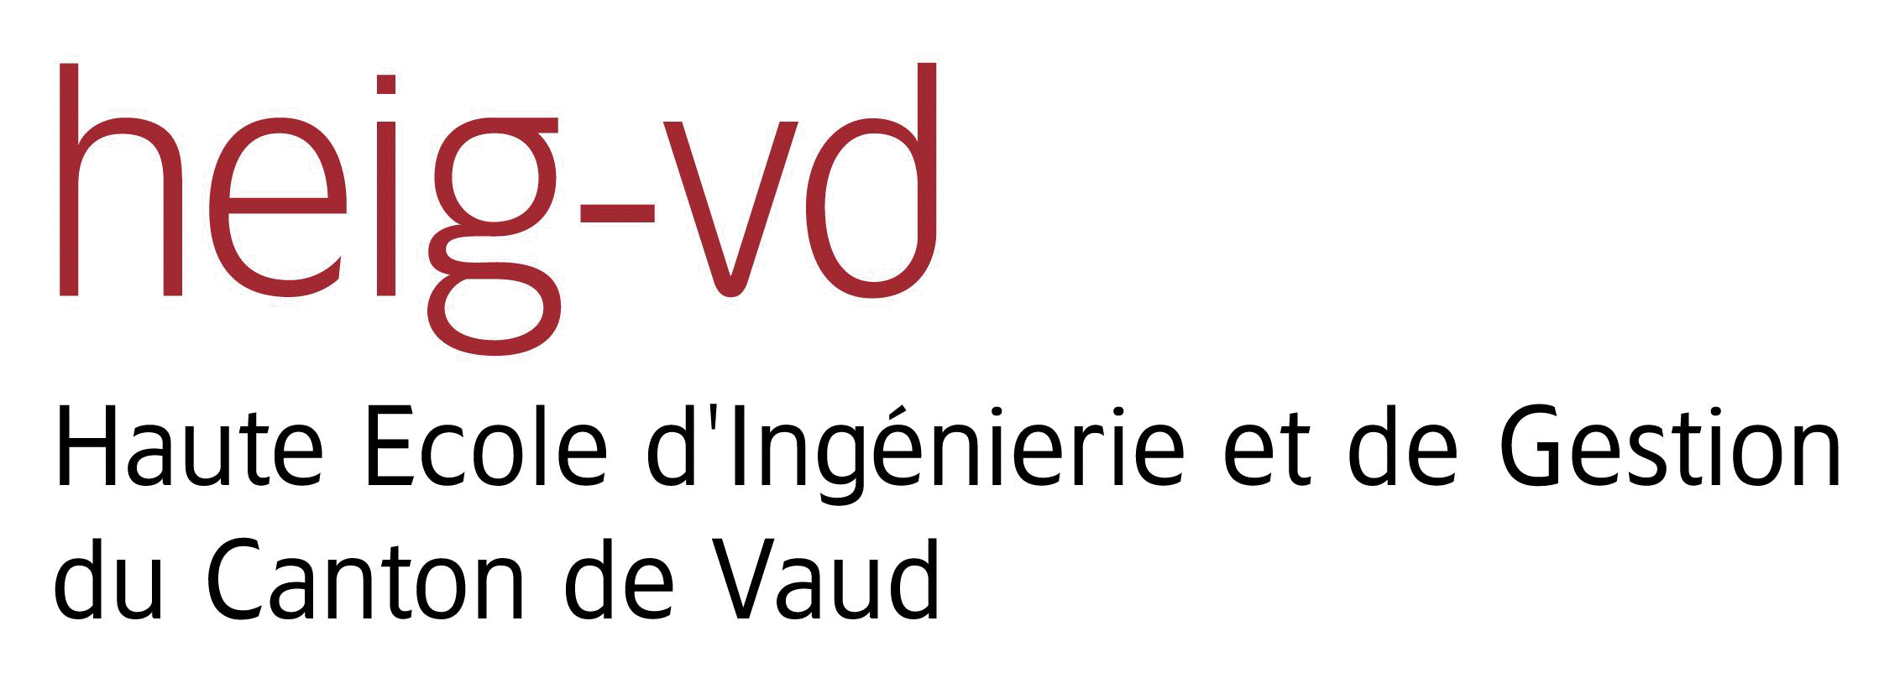



Suggested citation:

REYMONDIN, L. & PHAN, T. & NGUYEN, T. (2019). User Manual. Training Manual Terra-i. Version 3.

LIST OF TABLES 4

LIST OF FIGURE 5

Near-real-time monitoring system for the detection of vegetation loss in the tropics 7

Introduction 7

Medothology 7

Module I: 12

SOFTWARE REQUIREMENT, INPUT DATA MANAGEMENT, AND PROJECT 12

Summary 12

SOFTWARE REQUIREMENT 12

1.1. Complementary software installation in order to use Terra-i 12

1.1.1. Java Runtime Environment (JRE) Installation 12

1.1.2. Anaconda with Python 2.7 64 bit installation 14

1.1.3. Configuration Anaconda to create a independent Python runtime environment 16

1.1.4. SNAP Installation 18

1.1.5. Install libraries in Python 20

1.2. Installing of Terra-I system 22

1.2.1 Instructions for executing Terra-i use the CMD command in the Anaconda 22

1.2.2 Running the Terra-I functions 23

1.3. Input data 24

1.3.1. Sentinel-1 Image 24

1.3.2. Sentinel-2 image 25

1.4. Download data 25

Module II: 30

PRE-PROCESSING DATA 30

2.1. Input data 30

2.2. Workflow for processing 30

2.2.1 Clip images by region area 31

2.2.2 Apply orbit 32

2.2.3 Remove Thermal Noise 34

2.2.4 Calibration 36

2.2.5 Speckle Filter 39

2.2.6 Terrain Correction 43

Module III: 46

PROCESSING TERRA-I 3.0 46

3.1. Multi-temporal Image Analysis 46

3.1.1. Calculate cross-correlation 46

3.1.2. Convert data to Decibel (dB) 48

3.1.3. Calculate the difference between pairs of images 50

3.2. Develop a model to determine the threshold of change 51

3.3. Create a configuration file 53

3.4. Running Terra-i 55

3.5. Post-processing 56

# LIST OF TABLES

Table 1. Input parameters of script clipping image 31

Table 2. Input parameters of script applying orbit image. 33

Table 3. Describe parameters of script Remove Thermal Noise 35

Table 4. Describe parameters of Calibration 38

Table 5. Describe parameters of Terrain Correction 44

Table 6. Describe parameters of Coregistration 48

Table 7. Describe parameters of Convert data 49

Table 8. Describe parameters of DifferenceImage function 50

Table 9. The steps to indentify the threshold 52

Table 10. Describe parameters of change detection function 55

Table 11. The steps of convert data 56

# LIST OF FIGURE

Figure 1: Calculate different images 8

Figure 2: An ellipsoid determined by the mahalanobis distance r between x and the mean vector 9

Figure 3. Command to verify the java version installed in the machine 12

Figure 4. Message obtained when JRE is installed on the computer 13

Figure 5. Message obtained when JRE is not installed in the machine. 13

Figure 6: Visualization of the download page for JRE 14

Figure 7: Down Anaconda with python 2.7 14

Figure 8: Install Anaconda 15

Figure 9: Check the version of Anaconda 16

Figure 10: Open Anaconda navigator to create a new environment variable 16

Figure 11: Steps to create Python 2.7 64 bit environment variable on the Anaconda 17

Figure 12: Open CMD on Anaconda 17

Figure 13: Checking the installation of Python 2.7 18

Figure 14: Select and download SNAP toolboxes 18

Figure 15: Select destination directory 19

Figure 16: Installing components of SNAP 19

Figure 17: Configure SNAP for using with Python 20

Figure 18: Configure Terra-i to run on Python 22

Figure 19: List of functions of Terra-i 23

Figure 20: Cliping images by region 23

Figure 21: Sentinel-1 Image (radar) 24

Figure 22: Example about Sentinel-2 optical image 25

Figure 23: Register an account on website ESA 26

Figure 24: Filling in information 26

Figure 25: Script to download Sentinel-1 images 28

Figure 26: Commands to download Sentinel-1 images 28

Figure 27: Pre-processing sentinel- 30

Figure 28: Command to clip images by region area. 32

Figure 29: Script clipping image results 32

Figure 30: Apply orbits 32

Figure 31: Command to apply orbit function 33

Figure 32: Script ApplyOrbit results 34

Figure 33: Remove Thermal Noise 34

Figure 34: Commands to Remove Thermal Noise 35

Figure 35: Script RemoveThermalNoise results 36

Figure 36: Calibration. 37

Figure 37: Commands to run Calibration function 38

Figure 38. Script Calibration results 38

Figure 39. Speckle Filter using GAMA Map filter 42

Figure 40. Commands to run script Speckle filter 42

Figure 41. Terrain Correction 43

Figure 42. Commands to run script Terrain Correction 44

Figure 43. Script TerrainCorrection results 44

Figure 44. Flowchart of analyzing 46

Figure 45. Flowchart of inteferometric co-registration 47

Figure 46. Commands of sript Coregistration 48

Figure 47. Script Coregstration results 48

Figure 48. Commands to run script LineartoDB 49

Figure 49. Script LineartodB results 50

Figure 50. Commands to run script calculate the difference between pairs of images 51

Figure 51. Script Difference Image results 51

Figure 52. The steps calculate the threshold of change 52

Figure 53. Results of the calculation of threshold change model 53

Figure 54: **C**onfiguration file structure of Terrain system 54

Figure 55. Commands to run scrit ChangeDetection 55

Figure 56. Script ChangeDetection results 56

Figure 57. Commands to run script post-processing 57

Figure 58. **T**he results after running script 57

# Near-real-time monitoring system for the detection of vegetation loss in the tropics

# Introduction

Terra-i is a near real time monitoring system based on MODIS imagery for natural vegetation loss detection, first implemented in Latin America and under development in Asia and Africa. Since June 2012, Terra-i data have been available free of charge for download on www.terra-i.org. Besides the generation of the data, the Terra-i team has used these results for research, such as identification of areas with high risks of deforestation in near future, road impact assessment, protected areas effectiveness assessment, trends and rates analysis and many more. The latest version of Terra-i applied Sentinenl-1/2 and Landsat 8 images with a resolution of 10m, so it can detect land-use changes on small-scale, especially at district level as Di Linh of Lam Dong province and Tuong Duong district of Nghe An province. This is the main focus of developing the Terra-i system to better suit the current reality and geographical conditions, including the application of high-resolution images for better detection of small areas scale.

# Medothology

**Image Differencing**

**I**n this technique, images of the same area, obtained from times t1 and t2, are subtracted pixel wise. Mathematically, the difference image is:

$$∆I= I_{x-1}-I_{x}$$

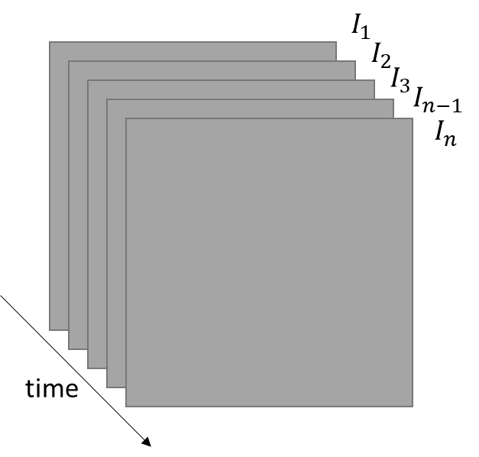

Figure 1: Calculate different images

**W**here Ix-1 and Ix are the images obtained from tx-1 and tx. The resulting image, ΔI, represents the intensity difference of Ix-1 from Ix. This technique works only if images are registered.

**L**et us define the difference of a pair of images for the radar cross-polarization bands VV and VH as a vector:

$$x=\left[\begin{matrix}∆VV \\ ∆VH\end{matrix}\right]$$

**A**s shown in section (to be written) x follows a bivariate normal distribution defined as:

$$x\sim N_{2}\left(μ,Σ\right)$$

**W**here μ is the 2 dimension mean vector and Σ is the covariance matrix:

$$Σ= \left[\begin{matrix}σ_{∆VV}^{2} & ρσ_{∆VV}σ_{∆VH} \\ ρσ_{∆VV}σ_{∆VH} & σ_{∆VH}^{2}\end{matrix}\right]$$

**W**here ρ is the correlation parameter and σ the standard deviation of ∆VV and ∆VH **T**rong đó ρ là hệ số tương quan và σ độ lệch chuẩn của ∆VV và ∆VH.

**Probability density function (pdf)**

**G**iven x is a 2 dimensional vector, it is a special case of the multivariate normal distribution and its probability density function can be written as follows:

$$pdf\left(x\right)=\frac{e^{-\frac{1}{2\left(1-ρ^{2}\right)}\left[\frac{{\left(x_{∆VV}-μ_{∆VV}\right)}^{2}}{σ_{∆VV}^{2}}+\frac{{\left(x_{∆VH}-μ_{∆VH}\right)}^{2}}{σ_{∆VH}^{2}}+\frac{\left(x_{∆VV}-μ_{∆VV}\right)\left(x_{∆VH}-μ_{∆VH}\right)}{σ_{∆VV}σ_{∆VH}}\right]}}{2πσ_{∆VV}σ_{∆VH}\sqrt{1-ρ^{2}}}$$

**Cumulative density function (cdf)**

**I**t has been proven that this function cannot be integrated analytically. However, there are ways to approximate the cumulative distribution function. For instance, (Bensimhoun, 2009) as shown how to compute the probability that a given point x is included inside an ellipsoid determined by the mahalanobis distance r between x and the mean vector μ as illustrated on Figure above.

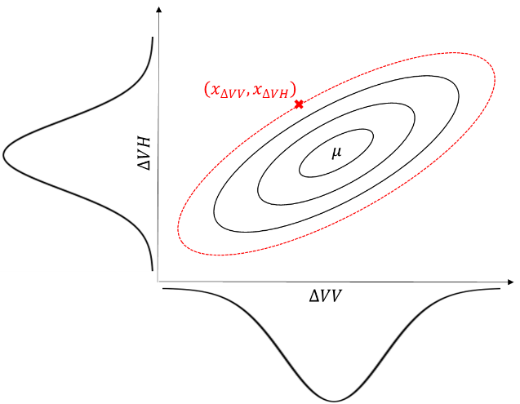

Figure 2: An ellipsoid determined by the mahalanobis distance r between x and the mean vector

**T**he interval defined by the mahalanobis distance r between x and the mean vector μ was shown by (Bensimhoun, 2009) to be:

$${\left(x-μ\right)}^{T}Σ^{-1}\left(x-μ\right)≤X_{k}^{2}\left(p\right)$$

**H**ere k represent the dimension of the vector x and $X_{k}^{2}\left(p\right)$ is the quantile function for probability p of the k degrees of freedom chi-squared distribution. In the bivariate case (k=2), Bensimhoun has shown that the chi-squared distribution simplifies to an exponential distribution of mean 2.

**T**his allows us to write the r distance as follow:

$$r^{2}={\left(x-μ\right)}^{T}Σ^{-1}\left(x-μ\right)$$

**A**nd given that Bensimhoun, 2009 showed that:

$$r^{2}\sim \frac{1}{2}e^{-\frac{r^{2}}{2}}$$

**W**e can define the CDF function as being:

$$F_{R}\left(r^{2}\right)=P\left(R≤r^{2}\right)=\int_{-∞}^{r}{\frac{1}{2}e^{-\frac{r^{2}}{2}}}dr=1-e^{-\frac{r^{2}}{2}}$$

**F**or processing purposes, let’s develop:

$$r^{2}={\left(x-μ\right)}^{T}Σ^{-1}\left(x-μ\right)$$

**L**et’s first define:

$$Σ^{-1}={\left[\begin{matrix}σ_{∆VV}^{2} & ρσ_{∆VV}σ_{∆VH} \\ ρσ_{∆VV}σ_{∆VH} & σ_{∆VH}^{2}\end{matrix}\right]}^{-1}$$

$$Σ^{-1}= \frac{1}{σ_{∆VV}^{2}σ_{∆VH}^{2}\left(1-ρ^{2}\right)}\left[\begin{matrix}σ_{∆VH}^{2} & -ρσ_{∆VV}σ_{∆VH} \\ -ρσ_{∆VV}σ_{∆VH} & σ_{∆VV}^{2}\end{matrix}\right]$$

With:

$$\frac{1}{\left|Σ\right|}= \frac{1}{σ_{∆VV}^{2}σ_{∆VH}^{2}\left(1-ρ^{2}\right)}$$

**W**e can now develop the multiplication, let’s start with:

$$\frac{1}{\left|Σ\right|}\left(\begin{matrix}x_{∆VV}-μ_{∆VV} & x_{∆VH}-μ_{∆VH}\end{matrix}\right)\left[\begin{matrix}σ_{∆VH}^{2} & -ρσ_{∆VV}σ_{∆VH} \\ -ρσ_{∆VV}σ_{∆VH} & σ_{∆VV}^{2}\end{matrix}\right]= \frac{1}{\left|Σ\right|}\left(\begin{matrix}σ_{∆VH}^{2}\left(x_{∆VV}-μ_{∆VV}\right)-ρσ_{∆VV}σ_{∆VH}\left(x_{∆VH}-μ_{∆VH}\right) & σ_{∆VV}^{2}\left(x_{∆VH}-μ_{∆VH}\right)-ρσ_{∆VV}σ_{∆VH}\left(x_{∆VV}-μ_{∆VV}\right)\end{matrix}\right)$$

**W**e can now multiply this by (x-μ):

$$r^{2} = \frac{1}{\left|Σ\right|}\left[\begin{matrix}σ_{∆VH}^{2}\left(x_{∆VV}-μ_{∆VV}\right)-ρσ_{∆VV}σ_{∆VH}\left(x_{∆VH}-μ_{∆VH}\right) & σ_{∆VV}^{2}\left(x_{∆VH}-μ_{∆VH}\right)-ρσ_{∆VV}σ_{∆VH}\left(x_{∆VV}-μ_{∆VV}\right)\end{matrix}\right]\left(\begin{matrix}x_{∆VV} -μ_{∆VV} \\ x_{∆VH} -μ_{∆VH}\end{matrix}\right)$$

$$r^{2}= \frac{1}{\left|Σ\right|}\left(σ_{∆VH}^{2}{\left(x_{∆VV}-μ_{∆VV}\right)}^{2}-ρσ_{∆VV}σ_{∆VH}\left(x_{∆VH}-μ_{∆VH}\right)\left(x_{∆VH}-μ_{∆VH}\right)+σ_{∆VV}^{2}{\left(x_{∆VH}-μ_{∆VH}\right)}^{2}-ρσ_{∆VV}σ_{∆VH}\left(x_{∆VH}-μ_{∆VH}\right)\left(x_{∆VH}-μ_{∆VH}\right)\right)$$

**F**inally, by rearranging the terms and interchange the full development of the determinant of Σ we can write $r^{2}$ as being:

$$r^{2}= \frac{1}{σ_{∆VV}^{2}σ_{∆VH}^{2}\left(1-ρ^{2}\right)}\left[σ_{∆VH}^{2}{\left(x_{∆VV}-μ_{∆VV}\right)}^{2}-2ρσ_{∆VV}σ_{∆VH}\left(x_{∆VH}-μ_{∆VH}\right)\left(x_{∆VH}-μ_{∆VH}\right)+σ_{∆VV}^{2}{\left(x_{∆VH}-μ_{∆VH}\right)}^{2}\right]$$

**T**o summarize, to compute the probability of observing a given 2 dimension point x inside an ellipsoid determined by the mahalanobis distance, one must first compute r:

$$r^{2}= \frac{σ_{∆VH}^{2}{\left(x_{∆VV}-μ_{∆VV}\right)}^{2}-2ρσ_{∆VV}σ_{∆VH}\left(x_{∆VV}-μ_{∆VV}\right)\left(x_{∆VH}-μ_{∆VH}\right)+σ_{∆VV}^{2}{\left(x_{∆VH}-μ_{∆VH}\right)}^{2}}{σ_{∆VV}^{2}σ_{∆VH}^{2}\left(1-ρ^{2}\right)}$$

**A**nd plug this $r^{2}$ value in the CDF of the chi-squared distribution with 2 degrees of freedom. Which was shown as to an exponential of mean 2.

$$F_{R}\left(r^{2}\right)=P\left(R≤r^{2}\right)=1-e^{-\frac{r^{2}}{2}}$$

**F**inally, our goal is to identify pixels that have a change with a magnitude and pattern that cannot be explained by the normal variation between a pair of images. In other words, we want to know how different is our vector x from the baseline. We define this difference as being the probability of falling outside of the ellipsoid.

$$D_{R}\left(r^{2}\right)=P\left(R>r^{2}\right)=1- D_{R}\left(r^{2}\right)=1-\left(1-e^{-\frac{r^{2}}{2}}\right)$$

$D_{R}\left(r^{2}\right)= e^{- \frac{r^{2}}{2}}$.

# Module I:

# SOFTWARE REQUIREMENT, INPUT DATA MANAGEMENT, AND PROJECT

# Summary

**T**he Module I of this document contains the description of the installation process of the Terra-i system as well as the necessary tools for its functioning. Procedures of acquisition of input data used by terra-i are also described. Finally, it shows the insights of the pre-processing stage, the methods and formats involved in each step of this stage.

# SOFTWARE REQUIREMENT

## Complementary software installation in order to use Terra-i

The programs that must be installed on the computer where Terra-i will be run are:

- Java Runtime Environment (JRE, JDK)

- Anaconda 3.6 with Python 2.7 64 bit.

### Java Runtime Environment (JRE) Installation

**Step 1:** To verify the java version installed in the machine, type **java -version** in the CMD window:

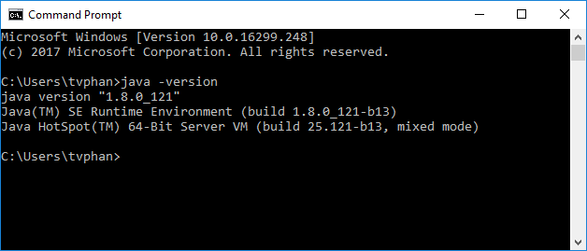

Figure 3. Command to verify the java version installed in the machine

**W**hen JRE is already installed the message displays the version.



Indicates that JRE is installed and the version installed on the computer

Figure 4. Message obtained when JRE is installed on the computer

**O**n the other hand, if JRE is not installed the user will see the message shown below:

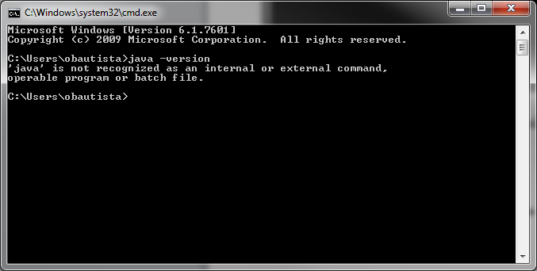

Figure 5. Message obtained when JRE is not installed in the machine.

**Step 2:** When installation is required:

* Download JRE latest version.

**Download link**: <http://www.oracle.com/technetwork/java/javase/downloads/index.html>

|  |  |
| --- | --- |
|  |  |

Figure 6: Visualization of the download page for JRE

* Run the installation file and follow the default steps.

**O**nce the installation has finished the user can verify the status by using the command described in step 1.

### Anaconda with Python 2.7 64 bit installation

**Step 1**: Download link: <https://www.anaconda.com/download/>:

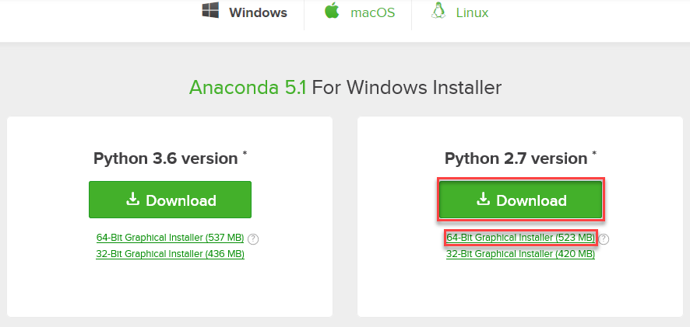

Figure 7: Down Anaconda with python 2.7

Select option Python 2.7 - 64-Bit.

**Step 2**: Run the installation file and follow the default steps

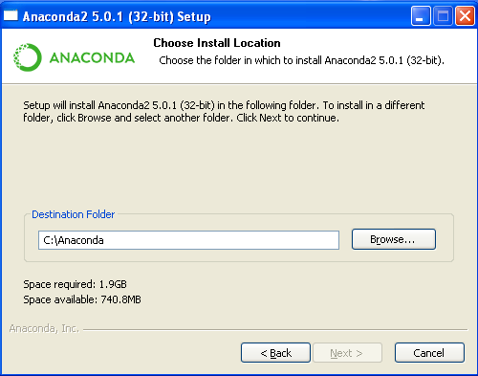

Figure 8: Install Anaconda

Step 3: In order to check Anaconda is already installed, open cmd and write **python --version:**

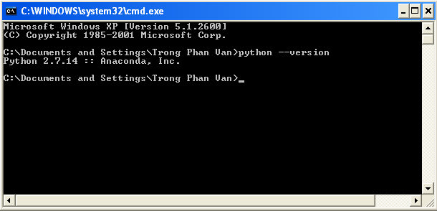

Figure 9: Check the version of Anaconda

### Configuration Anaconda to create a independent Python runtime environment

**Bước 1:** Click Start 🡪 Anaconda, then open Anaconda Navigator

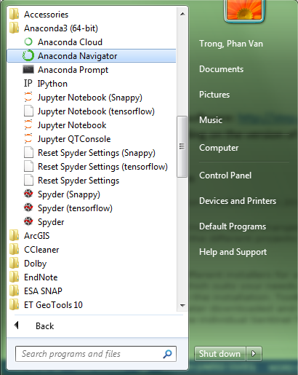

Figure 10: Open Anaconda navigator to create a new environment variable

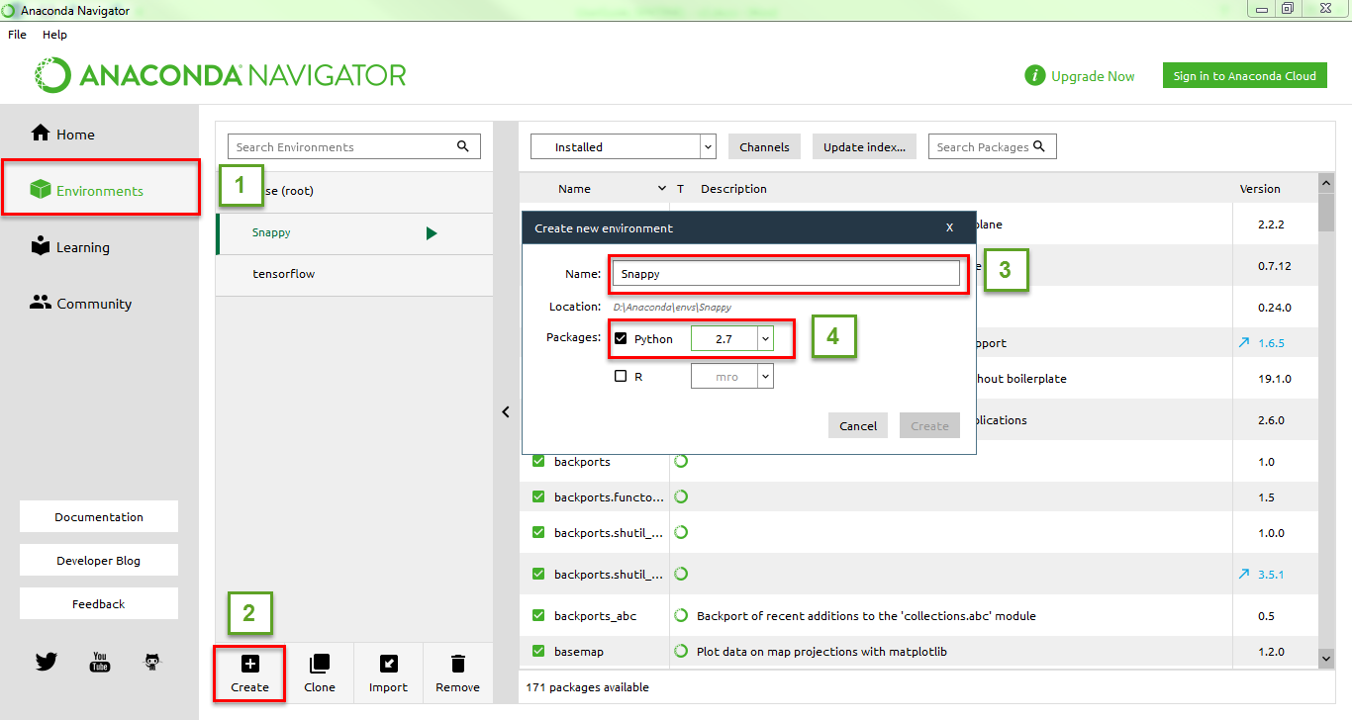

Figure 11: Steps to create Python 2.7 64 bit environment variable on the Anaconda

**T**he Python initialization process will take place automatically. Once completed to test, we perform the steps as shown below**:**

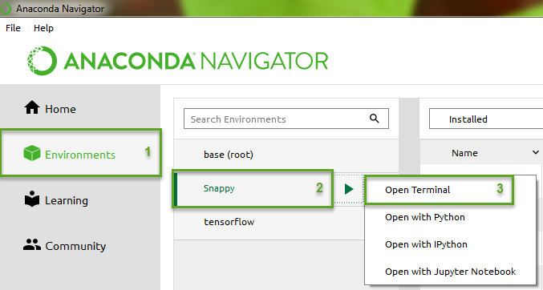

Figure 12: Open CMD on Anaconda

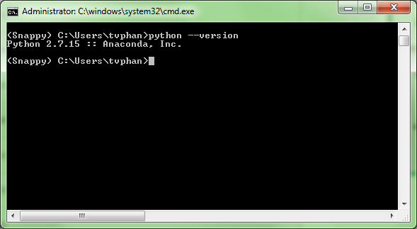

Figure 13: Checking the installation of Python 2.7

### SNAP Installation

**Step 1**: Download SNAP software: http://step.esa.int/main/download/ and select Window 64-bit version for All Toolboxes (depending on the version of your operating system that we download the appropriate version):

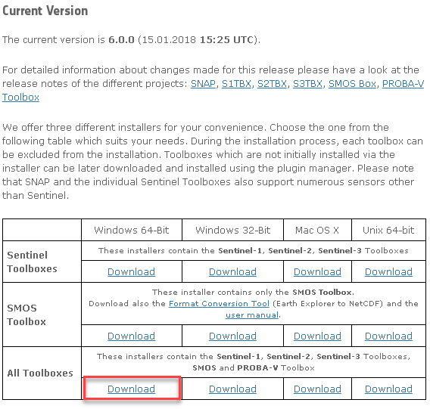

Figure 14: Select and download SNAP toolboxes

**Step 2**: Install SNAP toolboxes:

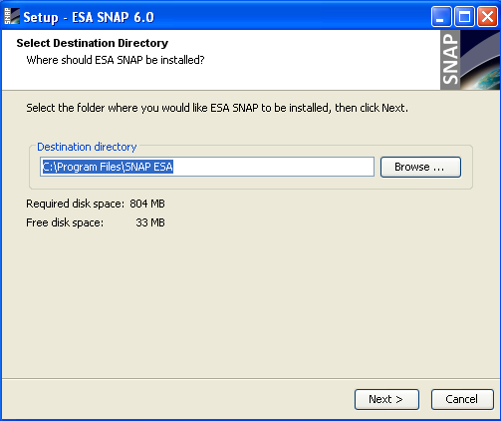

Figure 15: Select destination directory

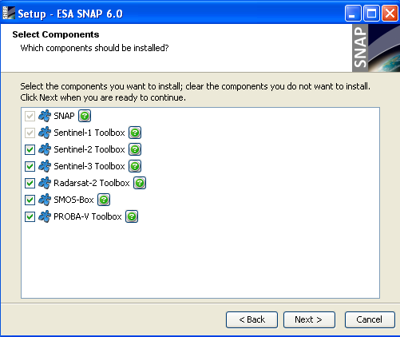

Figure 16: Installing components of SNAP

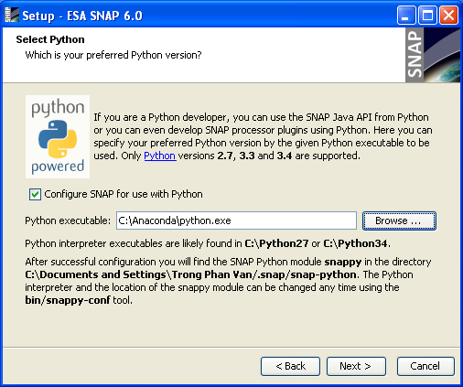

Figure 17: Configure SNAP for using with Python

Change the Memory Settings

**W**ithin **C:\Users\tvphan\.snap\snap-python\snappy** a file named **snappy.ini** is located. Here you can change how much memory snappy can use**:**

Change the line form

# java_max_mem: 4G

To e.g.

java_max_mem: 6G

**T**his means that snappy can use 6GB of you RAM. A recommended value is 70%-80% of the available RAM in your system. If we have a storng computer, we can increase the memory, this will increase processing of image.

### Install libraries in Python

**O**penAnaconda Navigator 🡪 Enviroments 🡪 Snappy 🡪 Open Terminal

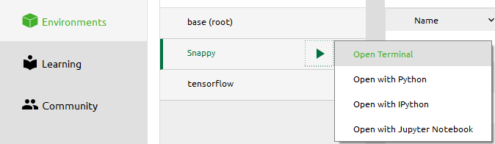

Then enter the following command: **python –m pip install “name of library”**

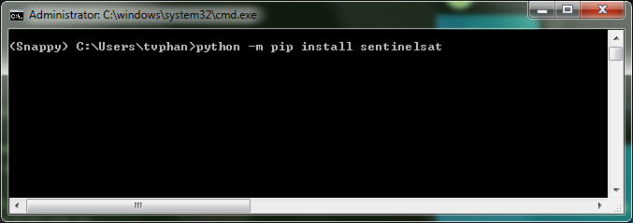

Table 1: List of library need to be installed

|  |  |  |
| --- | --- | --- |
| TT | package | Purpose |
| 1 | datetime | Library about date |
| 2 | numpy |  |
| 3 | glob | Group image into array |
| 4 | shutil |  |
| 5 | json | Read json file |
| 6 | geojson | Read json file |
| 7 | fiona | Library for processing raster image |
| 8 | rasterio | Library for processing raster image |
| 9 | gdal |  |
| 10 | zipfile | Extract file *.zip |
| 11 | sentinelsat | Using to download Sentinel-1 |

## Installing of Terra-I system

* + 1. **Instructions for executing Terra-i use the CMD command in the Anaconda**

**T**erra-i functions are configured to be run in parallel using a **JAVA and Python**. Therefore, Tera-i will be processed using command window. The first step to run Terra-i is **Open Anaconda Navigator 🡪 Environments 🡪 Snappy 🡪 Open Terminal**



**T**ype the full path where the Terra-i bin directory is located (tức là C:\Terra-i\bin) which contains codes to process images for forest change detection

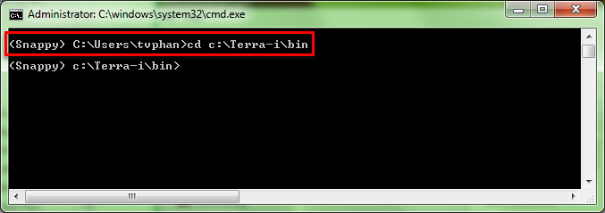

Figure 18: Configure Terra-i to run on Python

* + 1. **Running the Terra-I functions**

**T**erra-i contains the functions for step-by-step processing, which are numbered sequentially. We only need to do that step to run the system.

List of functions of Terra-i:

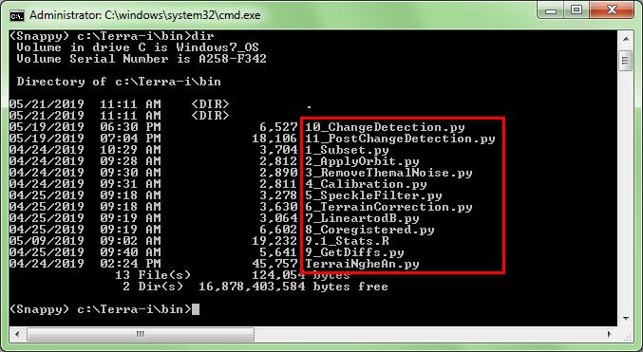

Figure 19: List of functions of Terra-i

**E**xample: In order to clip images by region, we can do following the figure below:

Gõ lệnh **python 1_Subset.py**

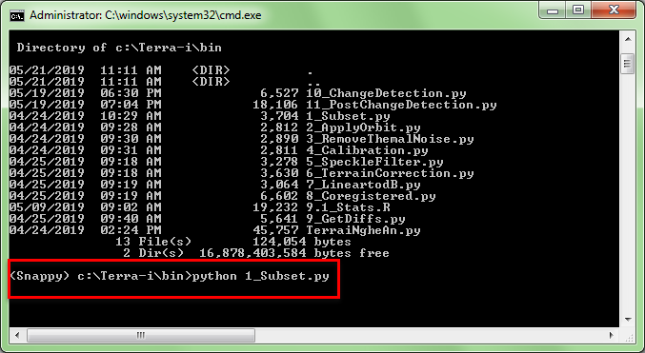

Figure 20: Cliping images by region

## Input data

## Sentinel-1 Image

**T**he goal of Terra-i system is to detect forest loss using Sentinel-1 Synthetic Aperture Radar (SAR) images. SAR data offers many advantages as it is little affected by cloud cover or a lack of illumination and thus can operate under all weather conditions as well as during day or night. Sentinel 1 mission is currently composed of two satellite Sentinel 1A and 1B. By combining the measurements from both satellites, a given site is visited every 6 day and absolutely free shared on the website <https://scihub.copernicus.eu/dhus>.

**S**entinel-1 sensor offers two measurements (bands) for each observed pixel. The magnitude of the waves that were transmitted vertically polarized and received vertically polarized (VV) and the magnitude of the waves that were transmitted vertically polarized and received horizontally polarized (VH) after being backscattered.

**N**onetheless, SAR data also has limitations when it comes to monitor vegetation in general and forest in particular. For instance, the images present speckles resulting from the high heterogeneity of the structure of forest canopy. SAR data are also limited in comparison to optical data when it comes to monitor the status of vegetation given the relatively reduced number of band available and the inexistent interaction between the vegetation chlorophyll and the SAR electromagnetic waves.

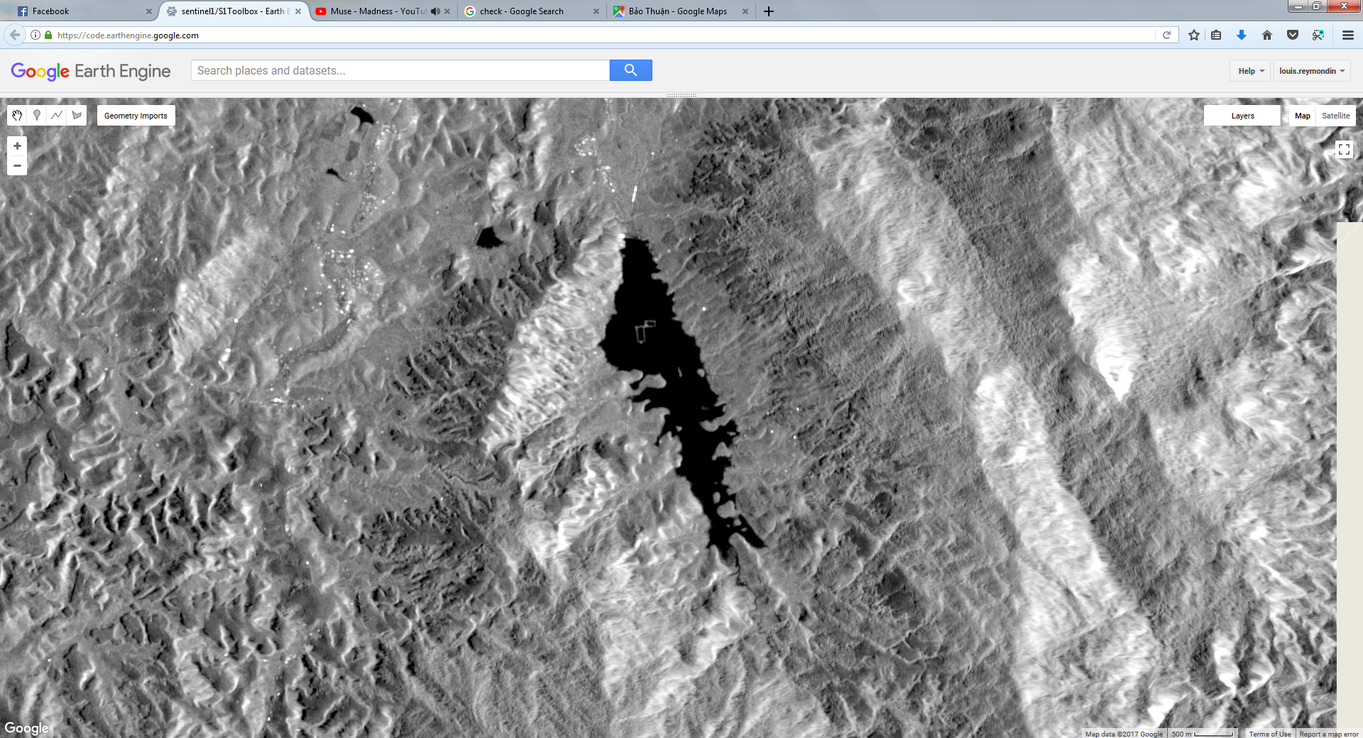

Figure 21: Sentinel-1 Image (radar)

**T**o overcome the issues due to the high heterogeneity of the forest canopy we first propose to mask all the none-forested areas using a pre-existing forest map built on Sentinel-2 optical data. The second step of this methodology is to identify abnormal changes between pair of consecutive images within forested areas.

## Sentinel-2 image

**S**entinel-2 has been known in recent years for high resolution and free satellite satellite images. Sentinel-2 data is provided by the European Union/ESA/Copernicus. Sentinel-2 data used for this study are data provided by Sentinel-2A optical satellite, with a resolution of 10 days.

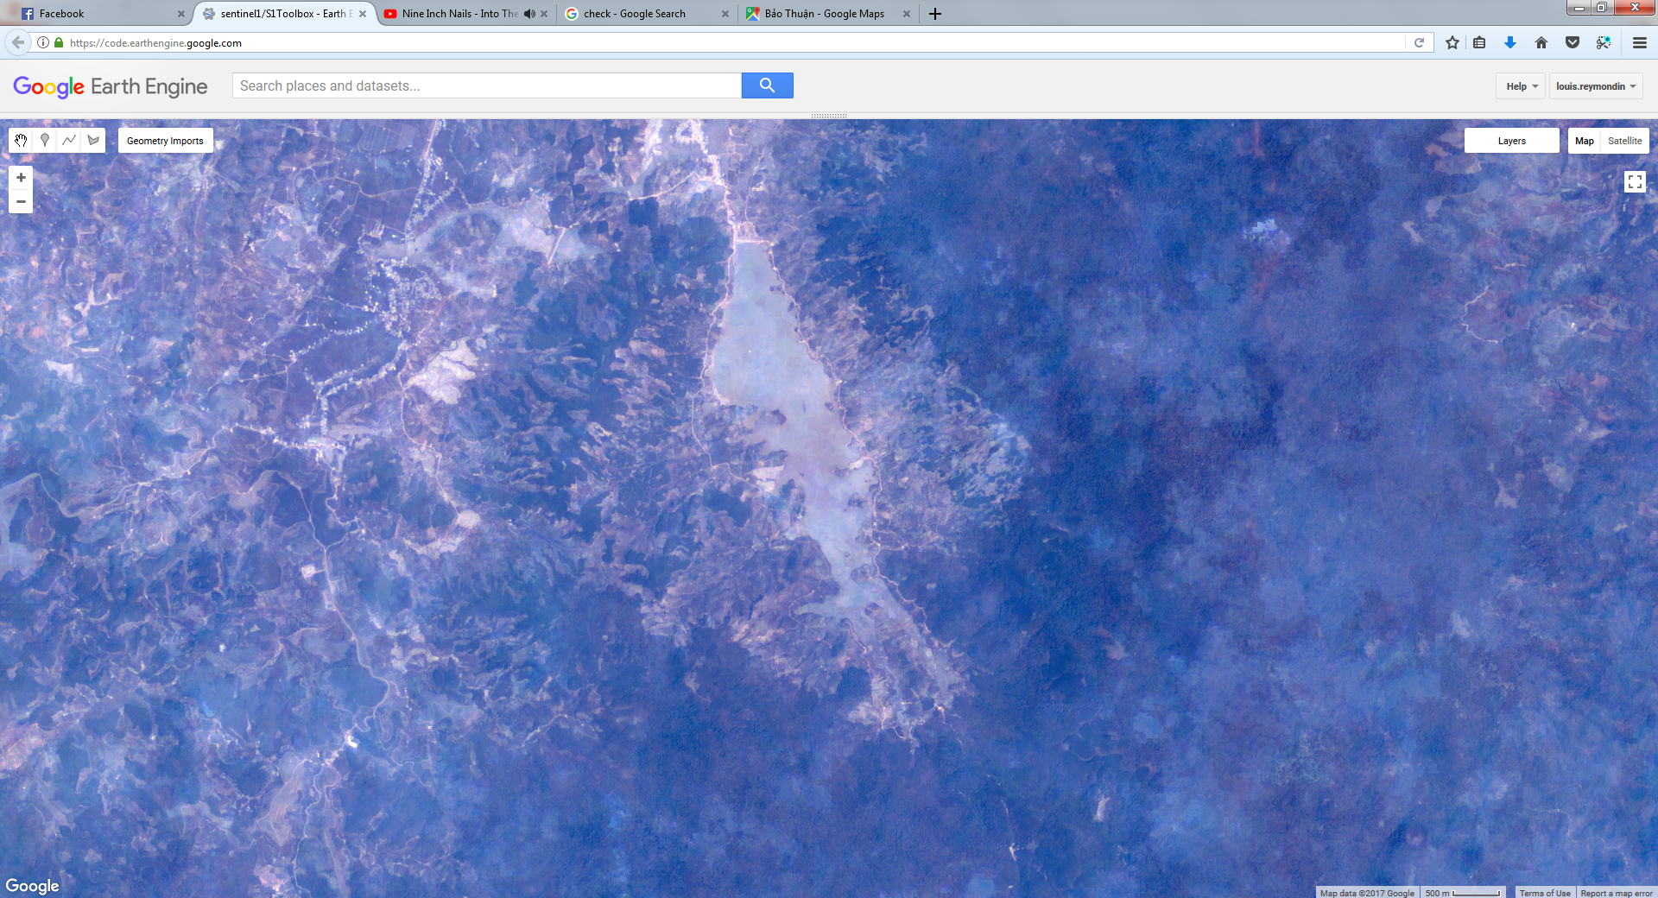

Figure 22: Example about Sentinel-2 optical image

## Download data

**T**erra-i contains a module for automatically downloading Sentinel-1 image data.

**Step 1**: Register an account on website: <https://scihub.copernicus.edu/dhus>

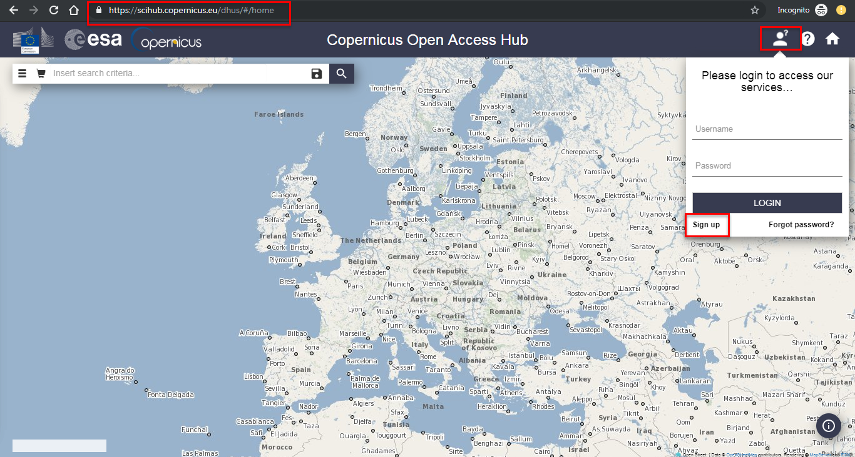

Figure 23: Register an account on website ESA

**A**fter clicking on the **Sign up** button of a window that appears, we will fill in information such as username, password and click the register button.

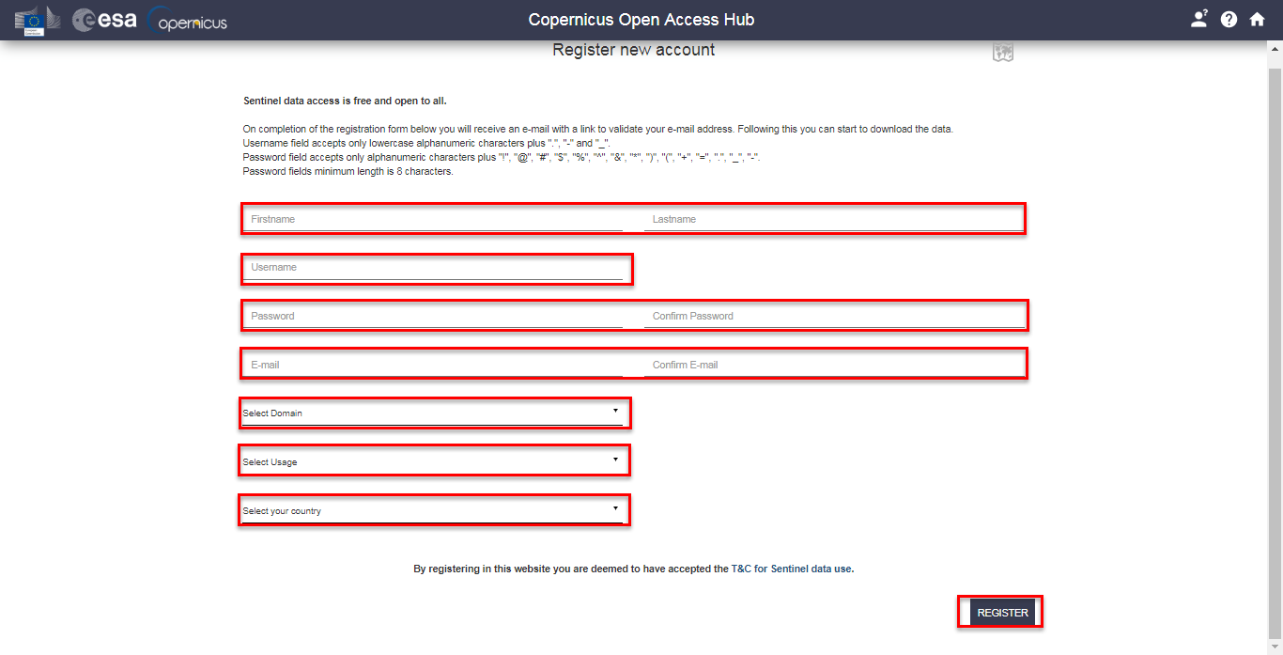

Figure 24: Filling in information

After successful registration, an email was sent to your inbox asking for registration verification, you only need to log in to the email to click on that link. So the account registration process was successful.

Step 2: The region area definition wants to download datand save it in **map.geojson** file



**Step** **3**: In folder **C:\Terra-i\config\download**, open file **download.py** using Notepad++ and fill in file username, password, then save it:



Figure 25: Script to download Sentinel-1 images

**Step 4**: Open command and Navigate to the folder containing 2 files **download.py và map.geojson**

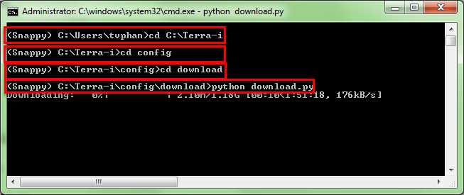

Figure 26: Commands to download Sentinel-1 images

**Terra-i Training Manual**

**MODULE II:**

**PRE-PROCESSING TERRA-I**



|  |  |
| --- | --- |
|  |  |
|  |  |







Suggested citation:

REYMONDIN, L. & PHAN, T. & NGUYEN, T. (2019). User Manual. Training Manual Terra-i. Version 3.

# Module II:

# PRE-PROCESSING DATA

## Input data

**S**entinel-1A is the first oil satellite in a series of satellites under the Copernicus program, which was launched on April 3, 2014. The device captures images of composite aperture radar, channel C (synthetic aperture radar (SAR).The image acquisition modes:

* Interferometric wide-swath mode, 250 km, 5×20 m resolution
* Wave-mode images 20×20 km, 5×5 m resolution (at 100 km intervals)
* Strip map mode 80 km swath, 5×5 m resolution
* Extra wide-swath mode 400 km, 20×40 m resolution

**S**entinel-1A is responsible for monitoring ice, oil spills, wind and waves, changing land use, terrain deformation and responding to flood and earthquake emergencies.

**S**ince radar data should have single polarization modes VV or HH and double polarization (VV + VH or HH + HV).

**P**rocessed Setinel-1 data will be in the * .dim format using some functions in the SNAP software developed by the European Space Agency.

## Workflow for processing

**I**n order to prepare input data for the model to detect deforestation changes, we must first take pre-processing steps to obtain the best data applied to the system.

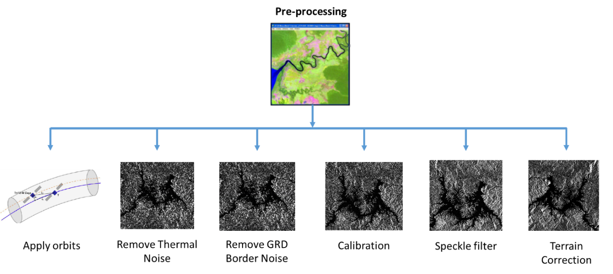

Figure 27: Pre-processing sentinel-



### Clip images by region area

**B**efore proceeding to image processing, we will cut the image according to the study area, because the RADAR image is very heavy, so we have to clip images before running the system.

* **Purpose: To clip iamge by region**
* **Directories**

Input data:

SENTINEL-1 - C:\Terra-i\Data\

Output data:

Subset – C:\Terra-i\Results\1.Subset

* **Parameters of script**

Table 1. Input parameters of script clipping image

|  |  |
| --- | --- |
| **Parameter** | **Describe** |
| Folder Sentinel-1 data | Path where the images data are stored (i.e. C:\Terra-i\Data\). |
| wkt | The information about the coordinates of the 4 corner of the study area or the coodinates of the shapefiles is converted to longitude and latitude  VD: POLYGON((104.400654 19.288912, 104.731820 19.288912, 104.731820 18.980120, 104.400654 18.980120, 104.400654 19.288912, 104.400654 19.288912)) |
| Metadata | Information about metadata of image |
| Output | Path of output folder (is automatically created) |

* **Command to clip images**

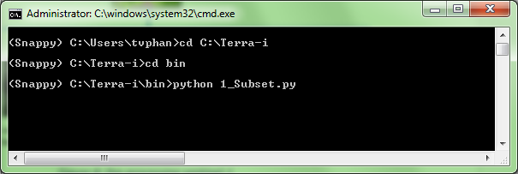

Figure 28: Command to clip images by region area.

**W**hen processing is done, the data will be saved in the directory.

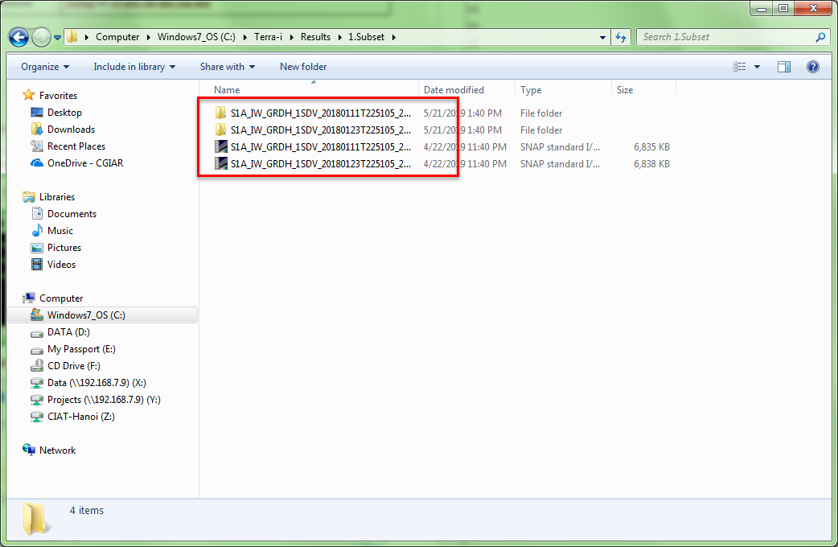

Figure 29: Script clipping image results

### Apply orbit

**T**he orbit state vectors provided in the metadata of a SAR product are generally not accurate and can be refined with the precise orbit files which are available days-to-weeks after the generation of the product.

**T**he orbit file provides accurate satellite position and velocity information. Based on this information, the orbit state vectors in the abstract metadata of the product are updated**.**

.

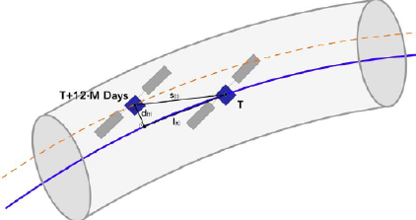

Figure 30: Apply orbits

**F**or Sentinel-1, Restituted orbit files and Preceise orbit files may be applied. Precise orbits are produced a few weeks after acquisition. Orbit files are automatically download from Array's servers. If an orbit file is not found, you may try looking for it in <https://qc.sentinel1.eo.esa.int/> and placing the downloaded file into the auxdata folder.

Using script **2_ApplyOrbit.py** to appy orbit for images.

* **Purpose**

Correction the images is right orbit.

* **Directories**

Input data:

C:\Terra-i\Results\1.Subset

Output:

C:\Terra-i\Results\2.ApplyOrbit

* **Parameters of script**

Table 2. Input parameters of script applying orbit image.

|  |  |
| --- | --- |
| **Parameter** | **Describe** |
| DIM format | Path where the images data were clipped |
| Output | Path of output folder (is automatically created) |

* **Script to appy orbit**

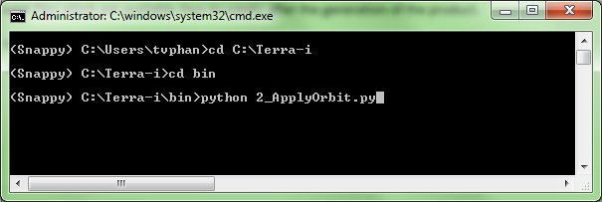

Figure 31: Command to apply orbit function

The results after running script

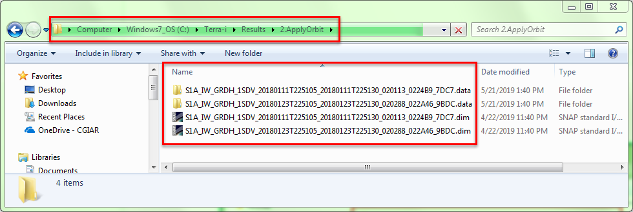

Figure 32: Script ApplyOrbit results

### Remove Thermal Noise

**T**hermal noise correction can be applied to Sentinel-1 Level-1 SLC products as well as Level-1 GRD products which have not already been corrected. Thermal noise removal uses the noise vectors to remove dark strips near scene edges with invalid data (this operation cannot be applied to some earlier images). All bursts in all sub-swaths are then seamlessly merged to form a single contiguous image per polarization band.

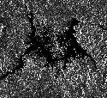

Figure 33: Remove Thermal Noise

* **Purpose**

Remove noise on images.

* **Directories**

Input data:

C:\Terra-i\Results\2.ApplyOrbit

Output:

C:\Terra-i\Results\3.RemoveThermalNoise

* **Parameters of script**

Table 3. Describe parameters of script Remove Thermal Noise

|  |  |
| --- | --- |
| **Parameters** | **Describe** |
| DIM format | Path where the images data were applied orbit |
| Output | Path of output folder (is automatically created) |

* **Commands to run script**

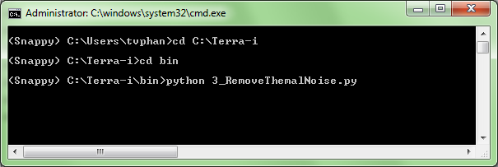

Figure 34: Commands to Remove Thermal Noise

The results after running script:

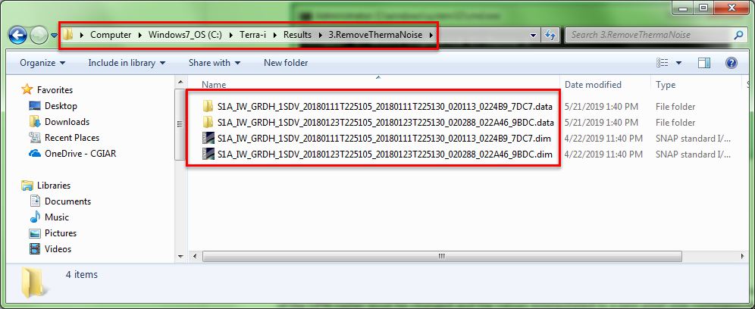

Figure 35: Script RemoveThermalNoise results

### Calibration

**T**he objective of SAR calibration is to provide imagery in which the pixel values can be directly related to the radar backscatter of the scene. Though un-calibrated SAR imagery is sufficient for qualitative use, calibrated SAR images are essential to quantitative use of SAR data.

**T**ypical SAR data processing, which produces level 1 images, does not include radiometric corrections and significant radiometric bias remains. Therefore, it is necessary to apply the radiometric correction to SAR images so that the pixel values of the SAR images truly represent the radar backscatter of the reflecting surface. The radiometric correction is also necessary for the comparison of SAR images acquired with different sensors, or acquired from the same sensor but at different times, in different modes, or processed by different processors.

**T**o make time series comparable, radiometric calibration computes backscatter intensity using sensor calibration parameters in the GRD metadata

**F**or converting digital pixel values to radiometrically calibrated backscatter, all the required information can be found in the product. A calibration vector is included as an annotation in the product allowing simple conversion of image intensity values into sigma or gamma nought values.

**T**he objective of SAR calibration is to provide imagery in which the pixel values can be directly related to the radar backscatter of the scene. To do this, the application output scaling applied by the processor must be undone and the desired scaling must be applied. Level-1 products provide four calibration Look Up Tables (LUTs) to produce β0i, σ0i and γi or to return to the Digital Number (DN). The LUTs apply a range-dependent gain including the absolute calibration constant. For GRD products, a constant offset is also applied.

**T**he radiometric calibration is applied by the following equation:

[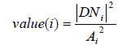](https://i.stack.imgur.com/EYyrr.png)

**W**here, depending on the selected LUT,

*value(i) = one of β0i, σ0i and γi or originalDNi.*

*Ai  = one of betaNought(i), sigmaNought(i), gamma(i) or dn(i)*

**B**i-linear interpolation is used for any pixels that fall between points in the LUT.

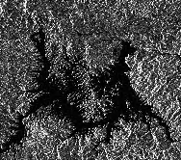

Figure 36: Calibration.

* **Purpose**

Convert scattering value to Digital Number value (DN).

* **Directories**

Input data:

C:\Terra-i\Results\3.RemoveThermalNoise

Output:

C:\Terra-i\Results\4.Calibration

* **Parameters of script**

Table 4. Describe parameters of Calibration

|  |  |
| --- | --- |
| **Parameters** | **Mô tả** |
| Folder Remove Thermal Noise | Remove Thermal Noise folder |
| Output data format( sigma or gamma) | Parameters of output data format is Sigma or Gamma |
| Output | Path of output folder (is automatically created) |

* ***Commands to run script***

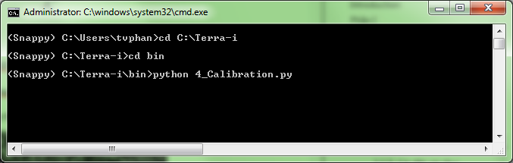

Figure 37: Commands to run Calibration function

The results after running script:

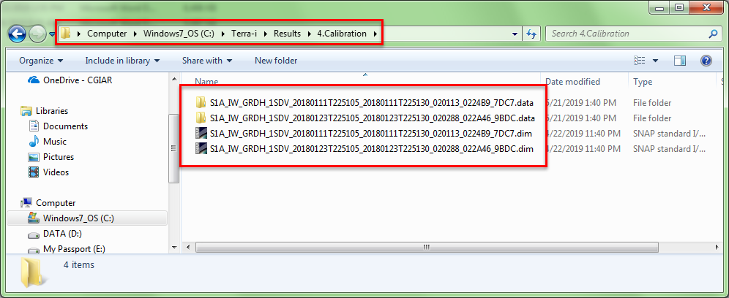

Figure 38. Script Calibration results

### Speckle Filter

**S**entinel-1A SAR provides a single C-band synthetic aperture radar instrument operating at a center frequency of 5.405 GHz. Sentinel-1A VH/VV dual polarization image, ground range detected and Interferometric Wide Swath mode is selected. The region filter is applied into three different test classes; shrimp farm, rubber and paddy rice areas as figure 2 VH and VV polarizations images are chosen to extract the backscattering coefficient. The four filters were applied with a kernel size of 3x3, 5x5, 7x7, 9x9 and 11x11 pixels for each case. All filters are applied to suppress the speckle noise in each area. The evaluation indicators used to select the optimal filtering technique are based on the first two statistical moments; the mean and the standard deviation (square root of the variance) are used to judge the ability to reduce speckle noise. A low standard deviation of backscatter within a homogeneous polygon is regarded as an indicator of higher class separability and the mean value is close to mean value of noisy image. Figure 3 presents the flowchart of the steps described above and gives an overview of the overarching methodological approach that was followed in order to select the best speckle noise reduction method tailored to the specifics of this application.

**S**AR images have inherent salt and pepper like texturing called speckles which degrade the quality of the image and make interpretation of features more difficult. Speckles are caused by random constructive and destructive interference of the de-phased but coherent return waves scattered by the elementary scatters within each resolution cell. Speckle noise reduction can be applied either by spatial filtering or multi-look processing.

**I**mages obtained from coherent sensors such as SAR system are characterized by speckle. This is a spatially random multiplicative noise due to coherent superposition of multiple backscatter sources within a SAR resolution element. In other words, the speckle is a statistical fluctuation associated with the radar reflectivity (brightness) of each image pixel.

**W**ithin the multi-temporal filtering an optimum weighting filter is introduced to balance differences in reflectivity between images at different times. It has to be pointed out that multi-temporal filtering is based on the assumption that the same resolution element on the ground is illuminated by the radar beam in the same way, and corresponds to the same coordinates in the image plane (sampled signal) in all images of the time series. The reflectivity can of course change from one time to the next due to a change in the dielectric and geometrical properties of the elementary scatters, but should not change due to a different position of the resolution element with respect to the radar.

**Gamma-MAP Filter**: The Gamma Maximum A Posteriori (MAP) filter was developed for single look intensity SAR images and perceived initially from Kuan et al. (1987). It is manipulating image statistics based on Bayesian analysis. It applies a spatial filter to each pixel in an image and filters the data based on local statistics of the central pixel value that is calculated using the neighboring pixels. The Gamma filter is similar to the Kuan filter but assumes that both the radar reflectivity and the speckle noise follow a Gamma distribution. The combination of these two distributions yield a K-distribution associated to a variety of typical radar return distributions over the earth surface (Gagnon and Jouan, etc.)

**L**et us represent the mm look-averaged SAR intensity image by the random variable G with mean ⟨G⟩=x, where x is the underlying signal. Then var (G) = x2/m and G is gamma-distributed with density function:

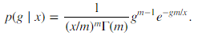

**L**et G=x*V. Then it follows that VV has the density

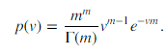

**T**herefore, in terms of the observed pixel intensities gg (realizations of GG), we can write

g=xv,

**W**here v is distributed as above, and has mean 1 and variance 1/m.

**B**ecause of this special multiplicative noise nature of speckle, conventional smoothing filters are not particularly suitable as an aid to SAR image interpretation.

**T**he gamma maximum a posteriori (gamma MAP) de-speckling filter may be derived from Bayes' Theorem. The a posteriori conditional probability for x, given intensity measurement is:

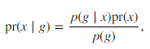

**W**here *p(g/x)*is given above, *pr(x)* is the prior probability for x and p(g) is the total probability density for g. This formulation allows us to include prior knowledge of the signal statistics (or texture) if available. An empirical statistical model for x is suggested by measurements of backscatter from ocean waves, namely:

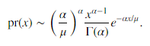

**T**his is just the gamma probability density with *β=μ/αβ=μ/α*, and hence with mean αβ=μαβ=μ and variance:

var(*x*)=*αβ*2=*μ*2/*α*.var(x)=αβ2=μ2/α.

**T**he parameters μμ and αα can be estimated as follows. By passing an *n×nn×n* window over the image we can obtain *g¯=⟨g⟩g¯=⟨g⟩* and *var(g)var(g).* Then the estimates are:

*μ*̂ =*g*¯, μ^=g¯,

**T**he prototype of MAP filters in spatial domain is the MAP filter. It assumes that both the radar reflectivity and the speckle noise follow a Gamma distribution and solves the MAP equation (21) accordingly. It is designed to smooth out noise while retaining edges or shape features in the image. Different filter sizes greatly affect the quality of processed images. If the filter is too small, the noise filtering algorithm is not effective. If the filter is too large, subtle details of the image will be lost in the filtering process. A 7 x 7 filter usually gives the best tradeoff.

**A** refined version of the GAMA-MAP filter that features an improved geometrical adaptively, analogously to Lee refined filter, was proposed in. The visual result appears in Figure .This achievement marks the beginning of a certain performance saturation in spatial despeckling methods, although highly sophisticated Bayesian methods in space domain, featuring MAP estimation associated to, e.g., Gauss-Markov and Gibbs random fields for prior modeling have been introduced later and are still used

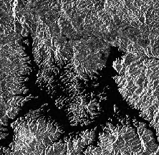

Figure 39. Speckle Filter using GAMA Map filter

* **Purpose**

Remove speckle to improve the quantity of image.

* **Directories**

Input data: C:\Terra-i\Results\4.Calibration

Output: C:\Terra-i\Results\5.SpeckleFilter

* **Commands to run Speckle Filter**

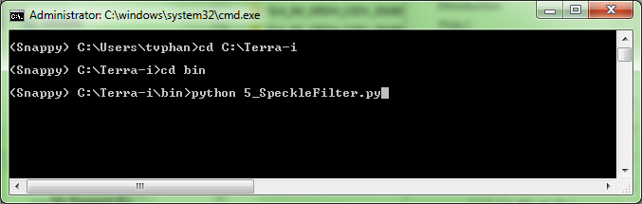

Figure 40. Commands to run script Speckle filter

### Terrain Correction

**O**rtho-rectification converts data from ground range geometry, which does not take terrain into account. The geometric correction has to consider the sensor and processor characteristics and thus must be based on a rigorous range-Doppler approach.

**D**ue to topographical variations of a scene and the tilt of the satellite sensor, distances can be distorted in the SAR images. Image data not directly at the sensor’s Nadir location will have some distortion. Terrain corrections are intended to compensate for these distortions so that the geometric representation of the image will be as close as possible to the real world.

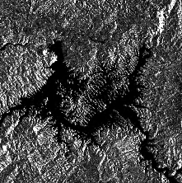

Figure 41. Terrain Correction

* **Purpose**

Terrain corrections image will be as close as possible to the real world.

* **Directories**

Input data:

C:\Terra-i\Results\5.SpeckleFilter

Output:

C:\Terra-i\Results\6. TerrainCorrection

* **Parameters of script**

Table 5. Describe parameters of Terrain Correction

|  |  |
| --- | --- |
| **Parameters** | **Describe** |
| Folder Speckle Filter | Path where the images were remove Speckle Filter |
| DEM ( STRM 1sec GHT) | Digital Elevation Model |
| WGS84 | The coordinate will be appied for the study area |
| Output | Path of output folder (is automatically created) |

* **Commands to run script**

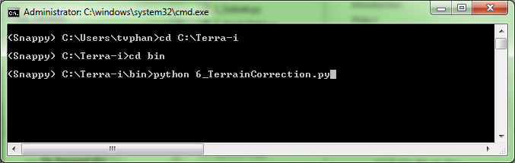

Figure 42. Commands to run script Terrain Correction

**T**he results after running script:

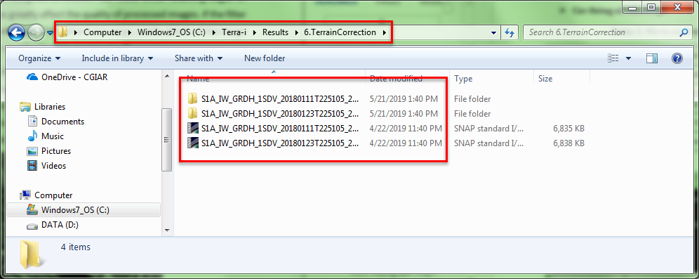

Figure 43. Script TerrainCorrection results

**Terra-i Training Manual**

**Module III**

**PROCESSING TERRA-I**



|  |  |
| --- | --- |
|  |  |
|  |  |







Suggested citation:

REYMONDIN, L. & PHAN T. & NGUYEN.T (2019). User Manual. Training Manual Terra-i. Version 3.

# Module III:

# PROCESSING TERRA-I 3.0

* 1. **Multi-temporal Image Analysis**

The goal of this step is to find out the difference between pairs of images and determine the difference between multi-temporal image sequences, the system must conduct a number of steps to detect the change.

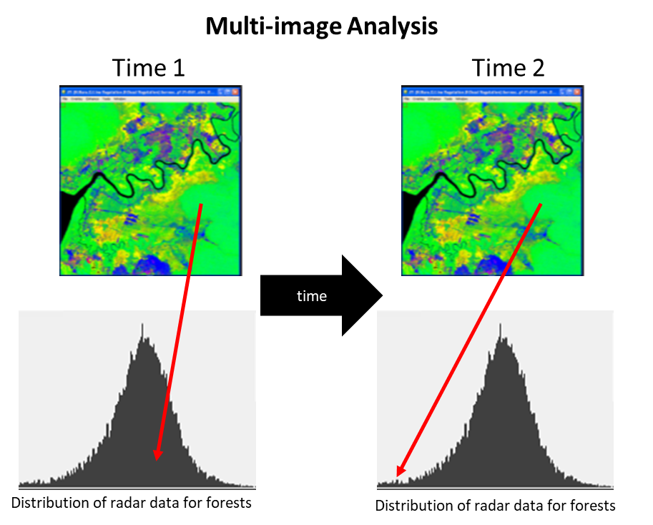

Figure 44. Flowchart of analyzing

* + 1. **Calculate cross-correlation**

**T**he sub-pixel coregistration of SAR images is a strict requirement and critical component of any interferometric processing chain. It is an essential step for the accurate determination of phase difference, and applications such as DEM map generation, interferometric deformation analysis, etc**.**

**T**he interferometric modules of the toolbox will accurately co-register one or more slave images with respect to a master image. The co-registration procedure is completely automatic. Apart from defining the processing parameters, no additional input nor intervention from the user is required. For example the distribution of correlation (optimization) windows are done in automatic manner for both master and slave image. Also, the refinement of the coregistration offsets is done in a fully automatic way, including downloading and interpolation of the a-priori digitial-elevation-model.

**T**he implementation of the coregistration procedure is based on the cross-correlation technique. The analysis process is shown in the figure below.

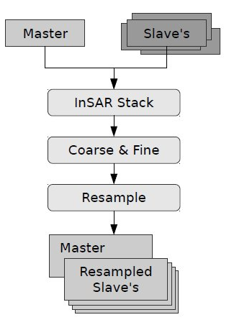

Figure 45. Flowchart of inteferometric co-registration

* **Purpose**

Analyzing of inteferometric co-registration.

* **Directories**

Input data:

C:\Terra-i\Results\6. TerrainCorrection

Output:

C:\Terra-i\Results\7.Coregistered

* **Parameters of script**

Table 6. Describe parameters of Coregistration

|  |  |
| --- | --- |
| **Parameters** | **Describe** |
| DIM format | Path folder of Terrain Correction |
| Stack | Stack 2 images into one |
| Cross_correllation | Calculate cross-correlation between the pairs of image |
| Output | Path of output folder (is automatically created) |

* **Commads of script**

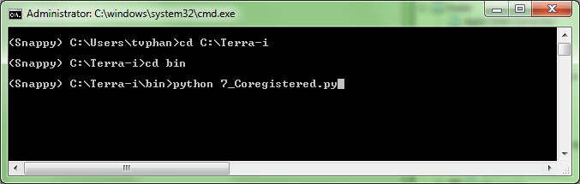

Figure 46. Commands of sript Coregistration

**T**he results after running script:

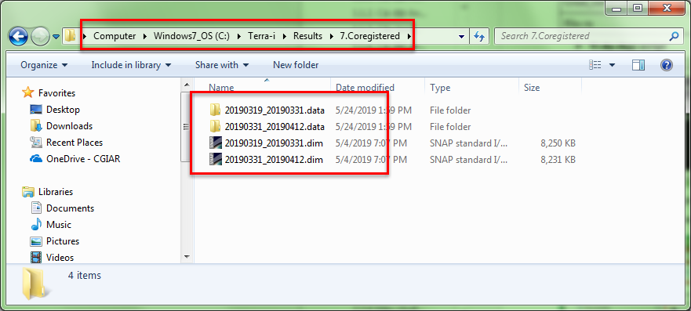

Figure 47. Script Coregstration results

* + 1. **Convert data to Decibel (dB)**
* **Purpose**

**A**fter analyzing the cross-correlation between pairs of images, we proceed to convert the reflectance data to decibel data (dB).

* **Directories**

**Input data:**

C:\Terra-i\Results\7.Coregistered

**Output:**

C:\Terra-i\Results\8.LinearTodB

* **Parameters of script**

Table 7. Describe parameters of Convert data

|  |  |
| --- | --- |
| **Parameters** | **Mô tả** |
| Input data | Path where the images were coregistered |
| Output | Path of output folder (is automatically created) |

* ***Commands to run script***

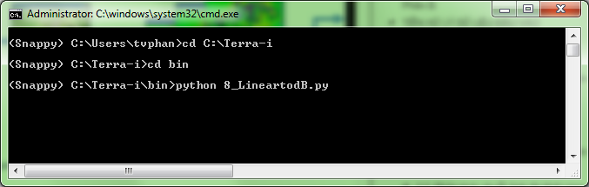

Figure 48. Commands to run script LineartoDB

**T**he results after running script:

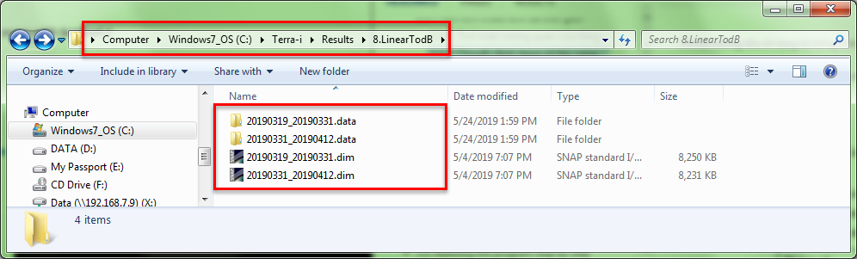

Figure 49. Script LineartodB results

* + 1. **Calculate the difference between pairs of images**
* **Purpose**

Calculate the difference between pairs of images

* **Diresctories**

**Input data:**

C:\Terra-i\Results\8.LinearTodB

**Output:**

C:\Terra-i\Results\9.DifferenceImage

* **Parameters of script**

Table 8. Describe parameters of DifferenceImage function

|  |  |
| --- | --- |
| **Parameters** | **Describe** |
| Input | Path where the images were converted |
| Output | Path of output folder (is automatically created) |

* ***Commands to run script***

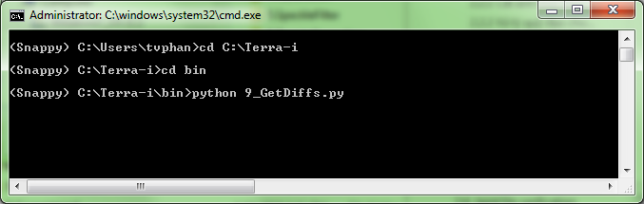

Figure 50. Commands to run script calculate the difference between pairs of images

**T**his step will have 2 output data for different purposes, the result after running the data stored on the following path:

* **Analysis:** Used for analyzing the threshold of change according to the methods described above.
* **Differences**: Differential index calculation images for purposes of detecting the changes

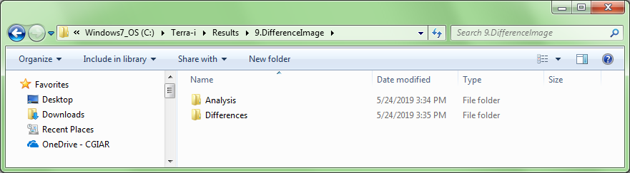

Figure 51. Script Difference Image results

* 1. **Develop a model to determine the threshold of change**

**T**he purpose of development this model is to calculate the threshold of change as input for the next step. To do this we need to prepare the following types of data:

* **I**mage data calculated the difference between pairs of images (data taken from image analysis steps above)
* **F**orest map in study area(depending on the type of forest we will separate for each type of forest, for example rich forest, poor forest, bamboo forest ...). One of the most important thing is that we only focus on the changes in the forest to the other classes we will delete it and only keep the forest class.
* **P**oint data created automatically in each forest type in the previous step. For each type of forest we will get about 1000 points for the model training data.

**A**fter preparing the data above, we proceed with the following steps:

Table 9. The steps to indentify the threshold

|  |  |  |
| --- | --- | --- |
| **ID** | **Step** | **Describe** |
| 1 | Points data | Input points to the model |
| 2 | Difference images | Input Diference images to the model |
| 3 | Combine iamges | Combine images into one image |
| 4 | Calculate the value for each type of forest for each point | Basing on image composite, calculate the value for each type of forest for each point, then export data to excel |
| 5 | Calculate Mean and Standart Deviation for 2 polarization VV and VH | Calculate Mean and Standart Deviation for 2 polarization VV and VH and do the same for others |
| 6 | Identify threshold | Calculate parameters for each forest |

**T**he steps are process in RStudio software

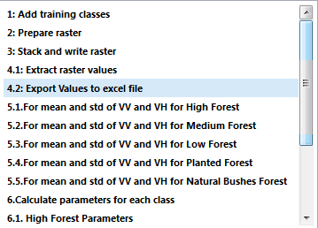

Figure 52. The steps calculate the threshold of change

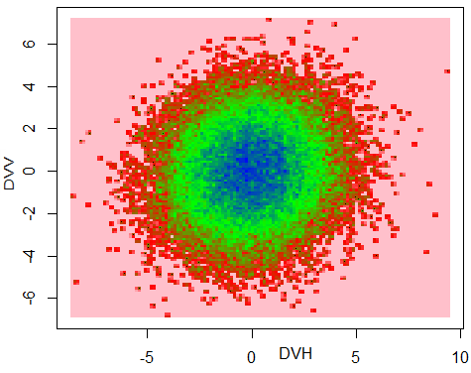

Figure 53. Results of the calculation of threshold change model

* 1. **Create a configuration file**

**C**onfiguration file structure of Terrain system:

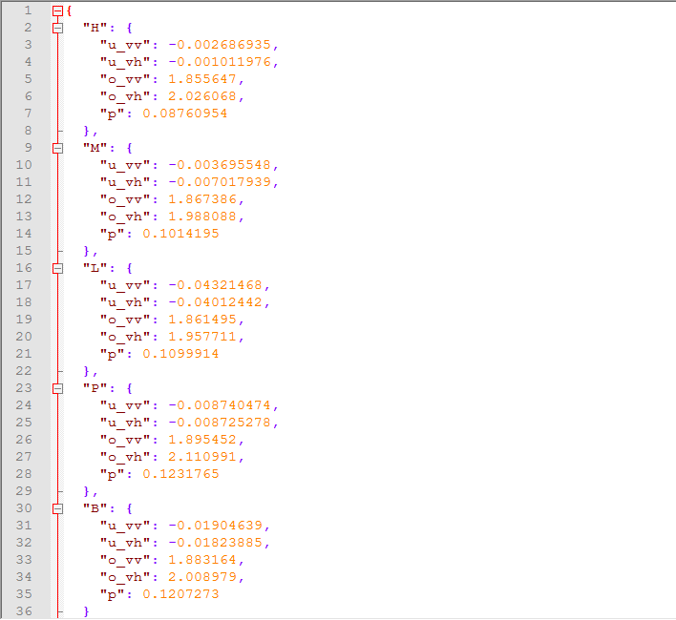

Figure 54: **C**onfiguration file structure of Terrain system

**C**onfig file was saved in folder **C:\Terra-i\config**

**Where: u: mean, o: standart deviation, p: correlltion between 2 polarization VV and VH.** These parameters are calculated for each type of forest separately.

* 1. **Running Terra-i**

Running Terra-i is based on the calculation formulas mentioned in the method section.

* **Purpose**

Calulate the changes.

* **Directories**

Input:

**C:\Terra-i\Results\9.DifferenceImage\Differences**

Output:

**C:\Terra-i\Results\10.ChangeDetection**

* **Parameters of script**

Table 10. Describe parameters of change detection function

|  |  |
| --- | --- |
| **Thông số** | **Mô tả** |
| Input | Path of folder Difference image |
| Parameters | The mean parameters, standard deviations, and correlations between the two polarization are taken from the file **config.json** |
| Output | Path of output folder (is automatically created) |

* **Commands to run script**

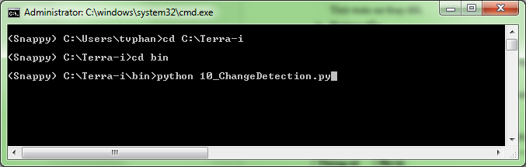

Figure 55. Commands to run scrit ChangeDetection

**T**he results after running script:

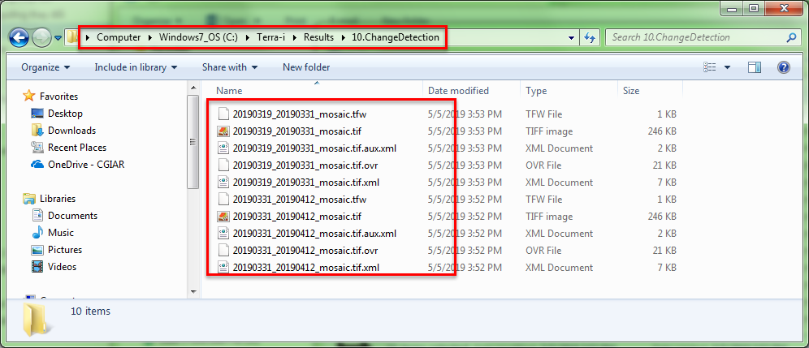

Figure 56. Script ChangeDetection results

* 1. **Post-processing**
* **Purpose**

Convert data format from raster to vector

* **Drectories**

Input:

**C:\Terra-i\Results\10.ChangeDetection**

Output:

**C:\Terra-i\Results\11.Post-ChangeDetection**

* **Parameters of script**

Table 11. The steps of convert data

|  |  |
| --- | --- |
| **Steps** | **Describe** |
| createShape | Convert raster to shapefile |
| convertProject | Convert the coordinate system of the shapefile to the expected coordinate system (currently in the WGS84 coordinates switch to UTM Zone 48N) and then calculate the area of change for each detected area. |
| intersection | For the purpose of viewing the deforestation is located in which the sub-zone, plot, plot, forest owner, etc. of the forest inventory map, we proceed to process this step. |
| Centroid | Convert data from polygon to point but the information still keep the same status for purposing showing on the map or website. |
| Output | Shapefile format |

* **Commands to run script**

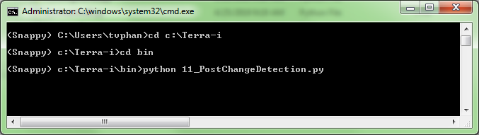

Figure 57. Commands to run script post-processing

**T**he results after running script:

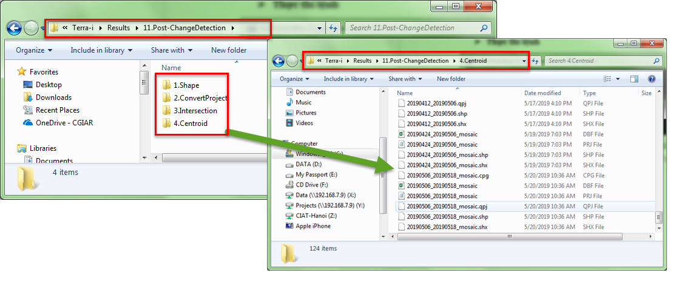

Figure 58. **T**he results after running script